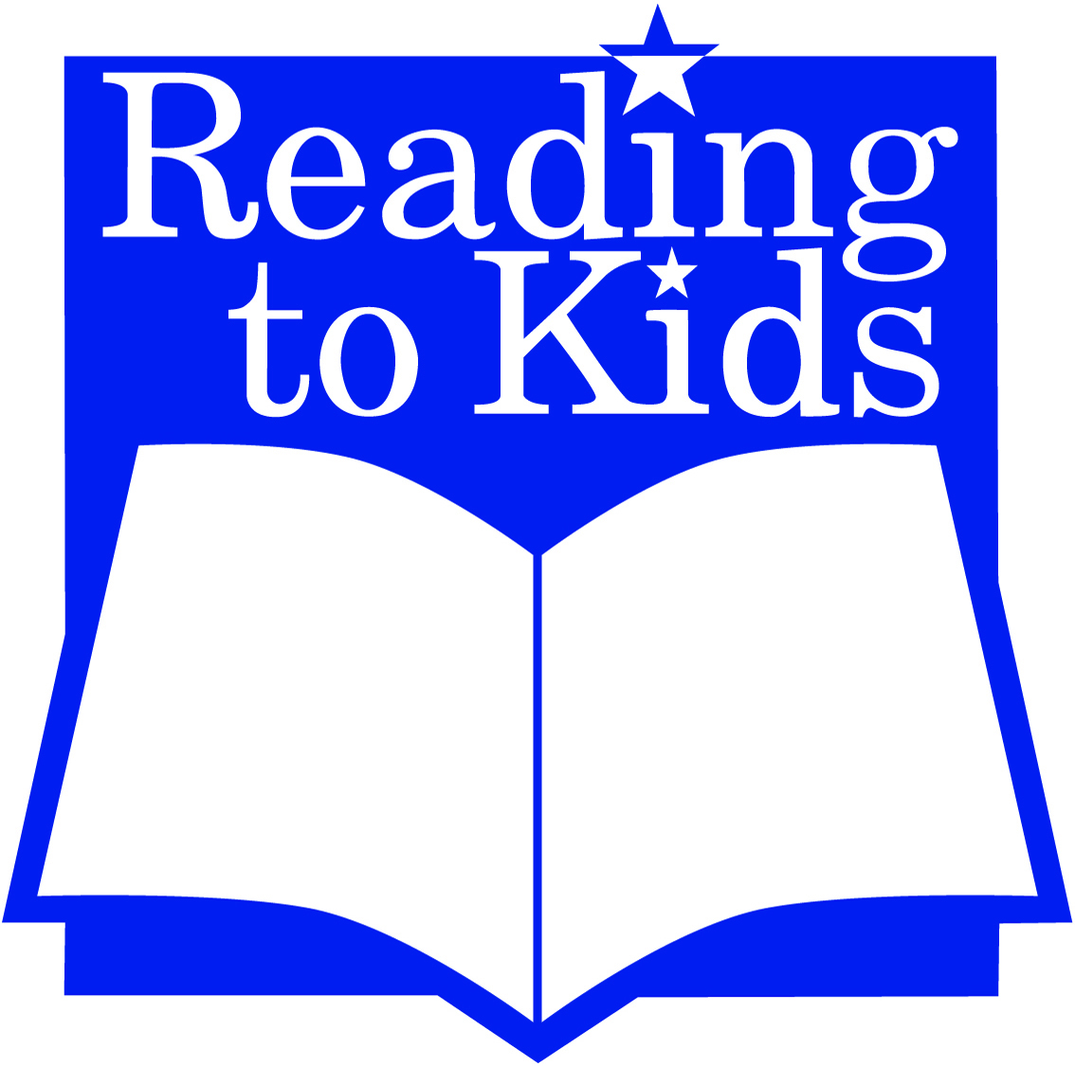

Inspiring children with a love of reading
DATE

DONOR NAME
COMPANY NAME
STREET ADDRESS
CITY, STATE ZIP

Dear DONOR,

I am a Reading to Kids volunteer, and I invite you to participate in our upcoming 20th Anniversary fundraiser, which will take place on Saturday, May 11, 2019 at the Santa Monica Bay Women’s Club.

Now in its 20th year, Reading to Kids, is a grassroots organization dedicated to inspiring underserved children with a love of reading, thereby enriching their lives and opportunities for success in the future. To this end, Reading to Kids gathers on average 620 children and 337 volunteers at reading clubs on the second Saturday of every month at eight Los Angeles elementary schools.

At the monthly reading clubs, pairs of volunteers read aloud to small groups of children, while their parents receive training on how to encourage their children to read at home. Kids, parents, teachers, and school libraries receive book donations at the end of the reading clubs. These are important donations, as 60 percent of low-income homes do not have age-appropriate reading materials for children.

In exchange for your contribution, your company or name will be publicized at the event and listed on all related silent auction signage. This donation is also fully tax-deductible, and Reading to Kids will provide all necessary documentation for tax purposes upon your donation.

We would love donated items to be received by May 3, 2019 at the Reading to Kids office. They can be sent to the attention of Special Events at 1600 Sawtelle Blvd, Los Angeles, CA 90025. I'm also more than happy to pick something up at your location. If you have any questions, please contact me at YOUR EMAIL ADDRESS and/or YOUR PHONE NUMBER.

Thank you for considering our request.

Very truly yours,

YOUR NAME
Reading to Kids volunteer

Reading to Kids is incorporated as a nonprofit corporation under the laws of the State of California and has been classified as an organization described in section 501(c)(3) of the federal Internal Revenue Code. The organization is exempt from both state and federal taxes. Their tax ID number is 95-4758698.

